How to setup a S2S VPN connection the 10M way
Made by following this guide https://blogs.technet.microsoft.com/jletsch/2016/03/15/lets-configure-azure-site-to-site-vpn-with-rras-in-azure-resource-manager/
- Setup the server that will host the Routing and Remote access feature
- Install the Remote Access server role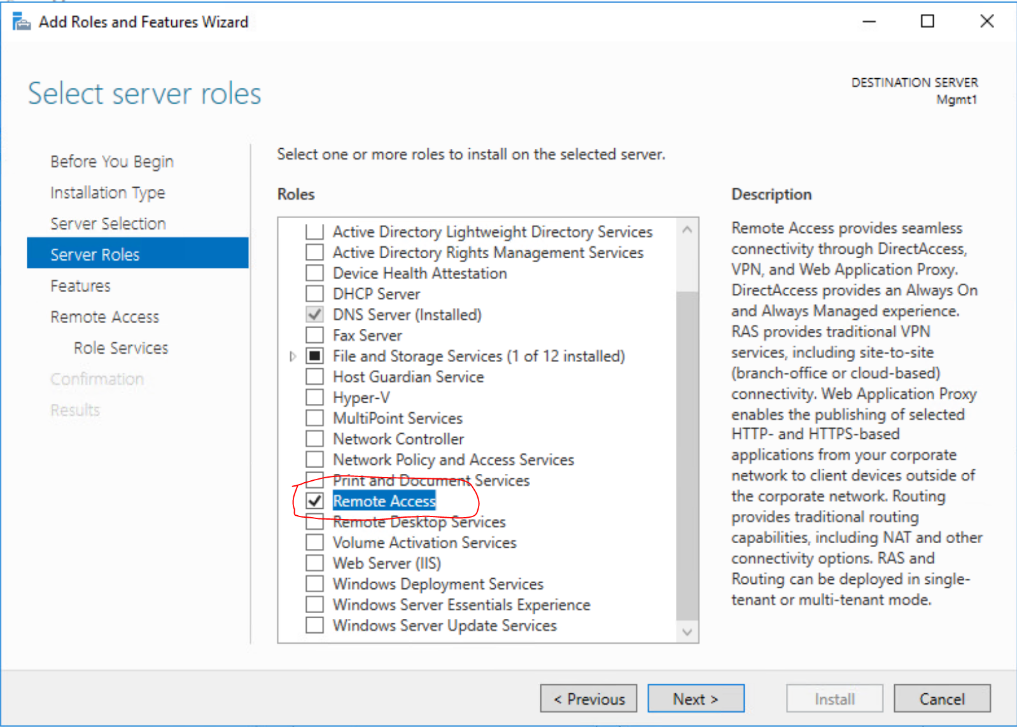
- Click next on features, no additional features need to be added
- Click next on the Remote Access tab
- Check all 3 boxes in role services.
  - When prompted, use the default and make sure “Install management tools” is checked as well.
  - Click Next
- Install the IIS server role, accept the defaults it gives, then confirm.
  - Reboot the server once the roles are installed.
  - 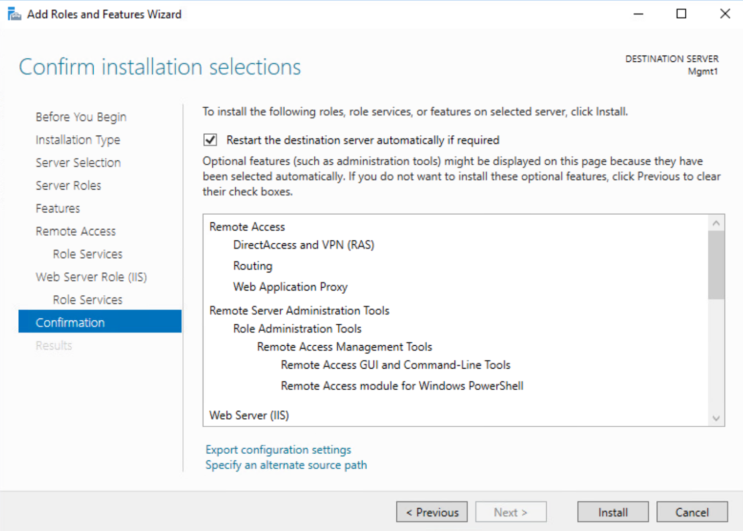
- Create an azure VNET with 10.1.1.0/24 (example IP, other sizes will work)
- Create a Gateway Subnet within the address space of the Vnet, atleast /28 in size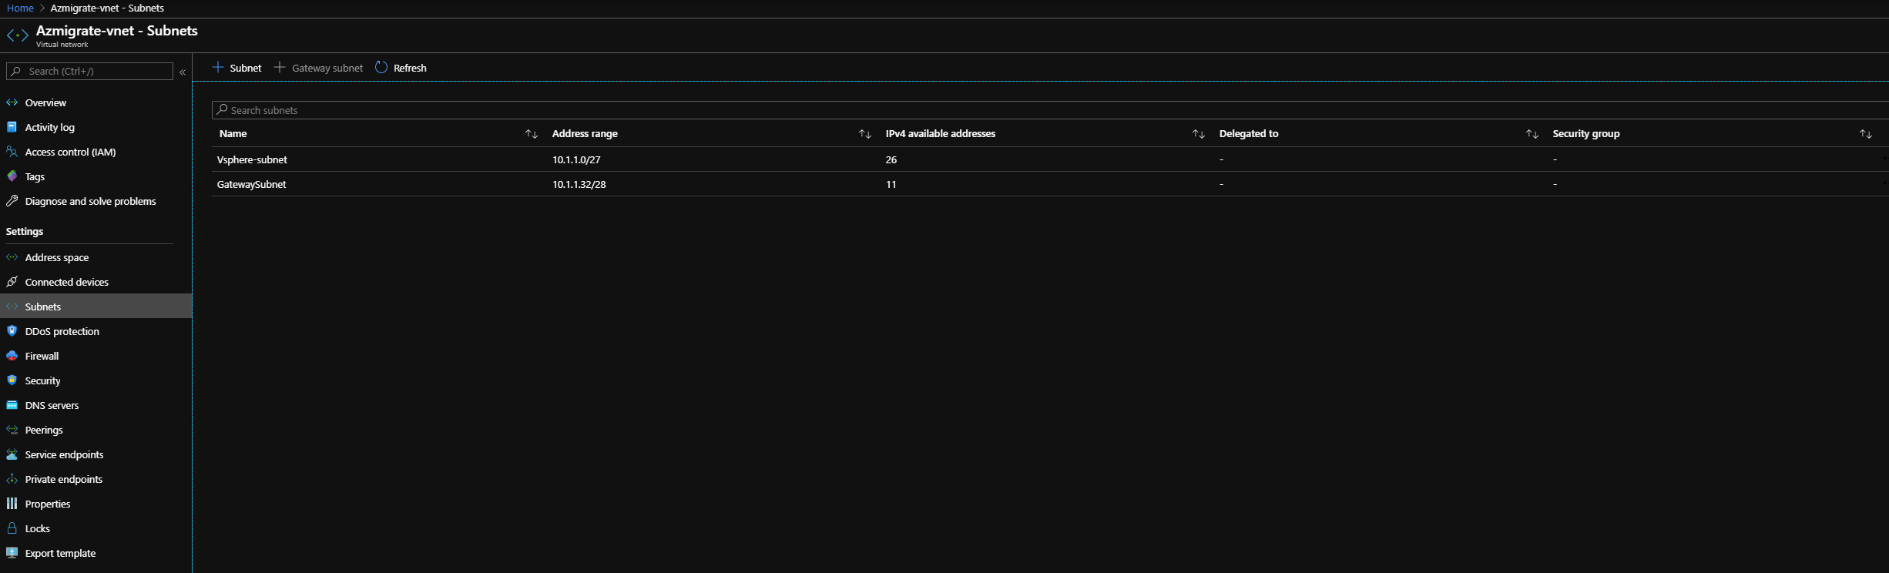
- Create a Virtual Network Gateway
  - 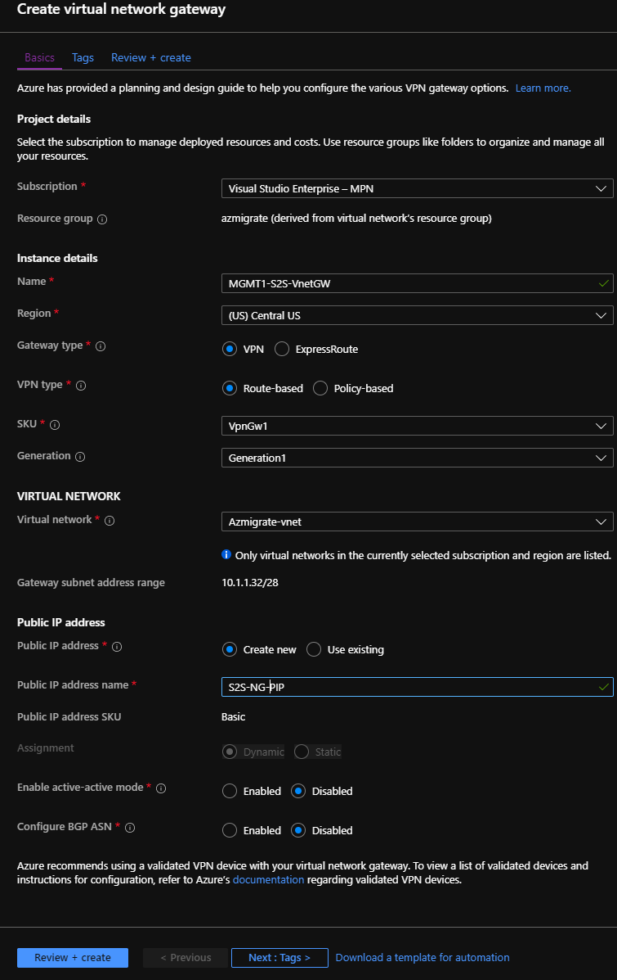
- Create the local network gateway
  - 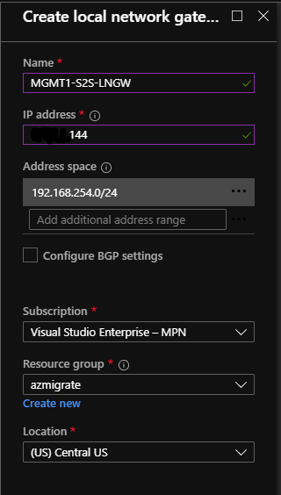
  - The IP Address will be the IP for the on-prem gateway
  - The address space will be the address space for you on prem network or on prem virtual network
- In your local network gateway, go to connections, and add a new connection
  - 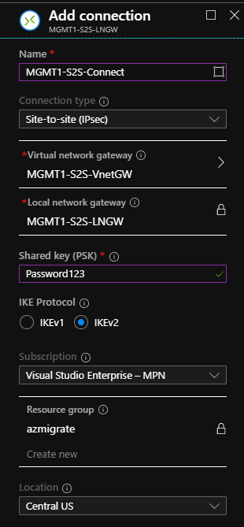
  - Define your preshared key in the connection blade. Make note of this key, you will need it again soon.
Return to the on prem server
- Open the routing and remote access tool. Right click on the server name then click Configure Routing and Remote Access Server
- Choose “Custom Configuration”
  - 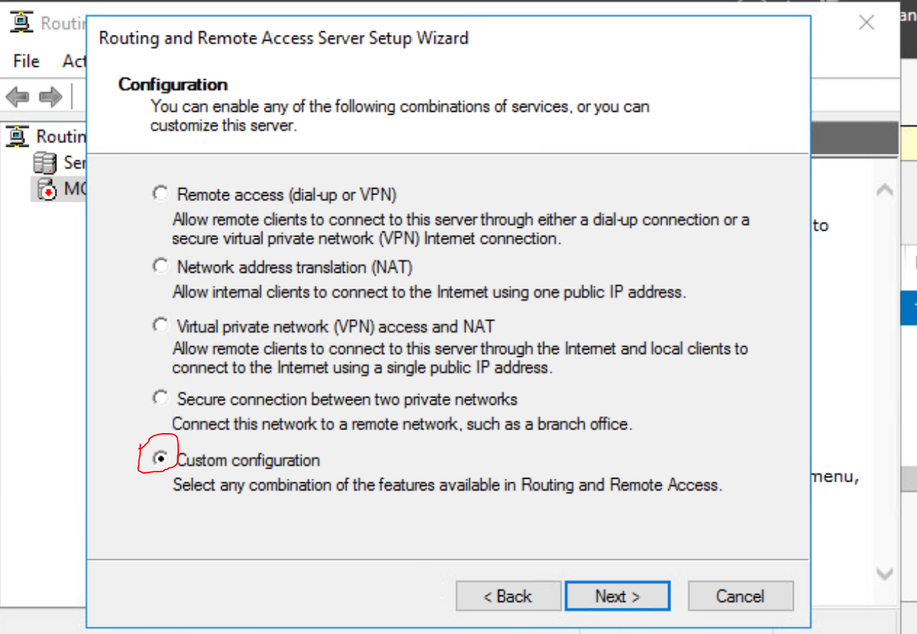
- Choose “Demand Dial” then finish, it may ask you to start the service.
  - 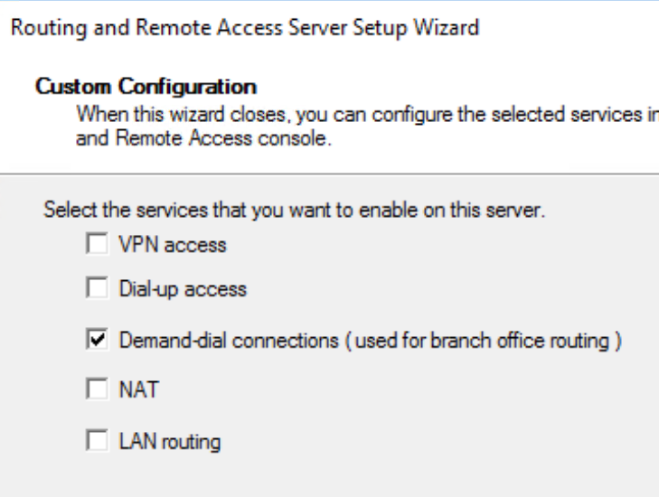
- If the Demand Dial interface does not popup on its own, right click network interfaces and choose “New demand dial interface” name it whatever you want.
  - Choose Connect using VPN
  - Choose Ikev2 as the vpn type
  - The destination address must be the Virtual Network Gateway Public IP address that you created earlier
  - Choose Route IP packets and interface
- If not prompted after completing the demand dial setup, click the drop down on IPV4 in the Routing and Remote Access tool. Right click static Routes, and add a new static route as shown.
  - 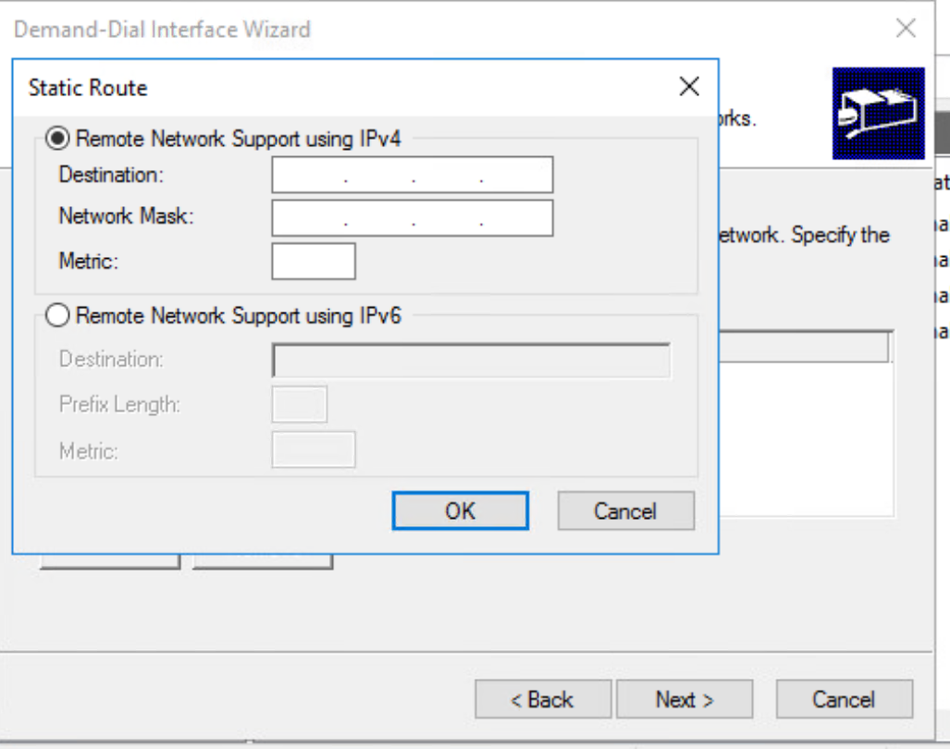
  - The destination will be the address space of your Azure VNET
  - The network will be the network mask of your Azure VNEt
  - The metric will be the CIDR range of the Azure VNet (/24)
  - After clicking ok then next, you will be prompted to add credentials
  - Make the user name “Azure”, leave the rest blank and press next then finish
  - 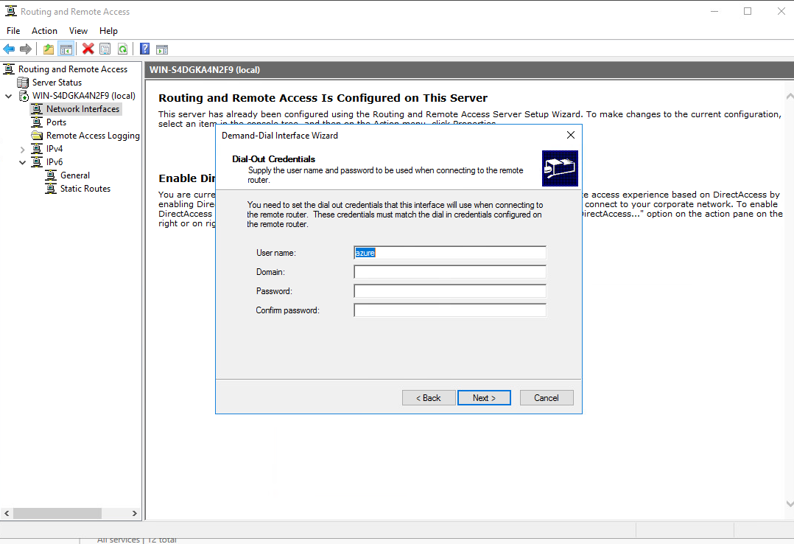
  - 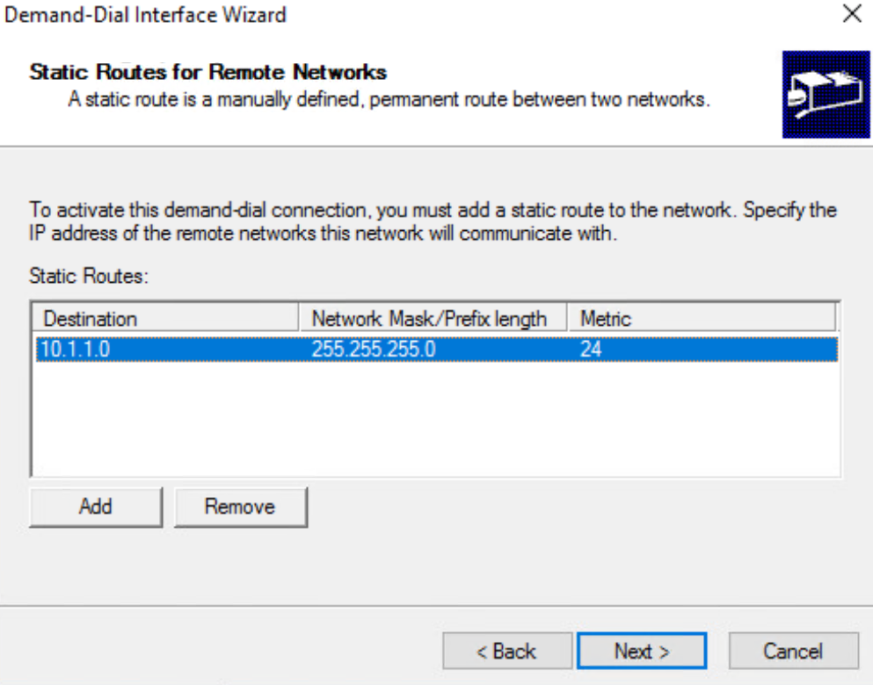

- Next, click on network interface under the server name. Choose your new Demand Dial interface that you created earlier, right click and choose properties.
- Enter the PreShared Key that you defined earlier in the Azure S2S connection.
- Then right click the demand dial interface again and connect, if you do not receive an error then it has worked.
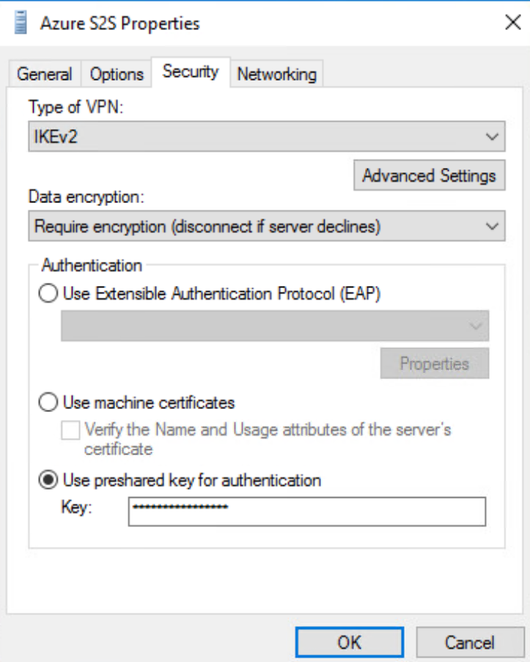
- You can test your connection by creating a VM that is in your Azure VNET. Then remote to the VMs private IP address from your RRAS server.

